1. **Queries** **101**

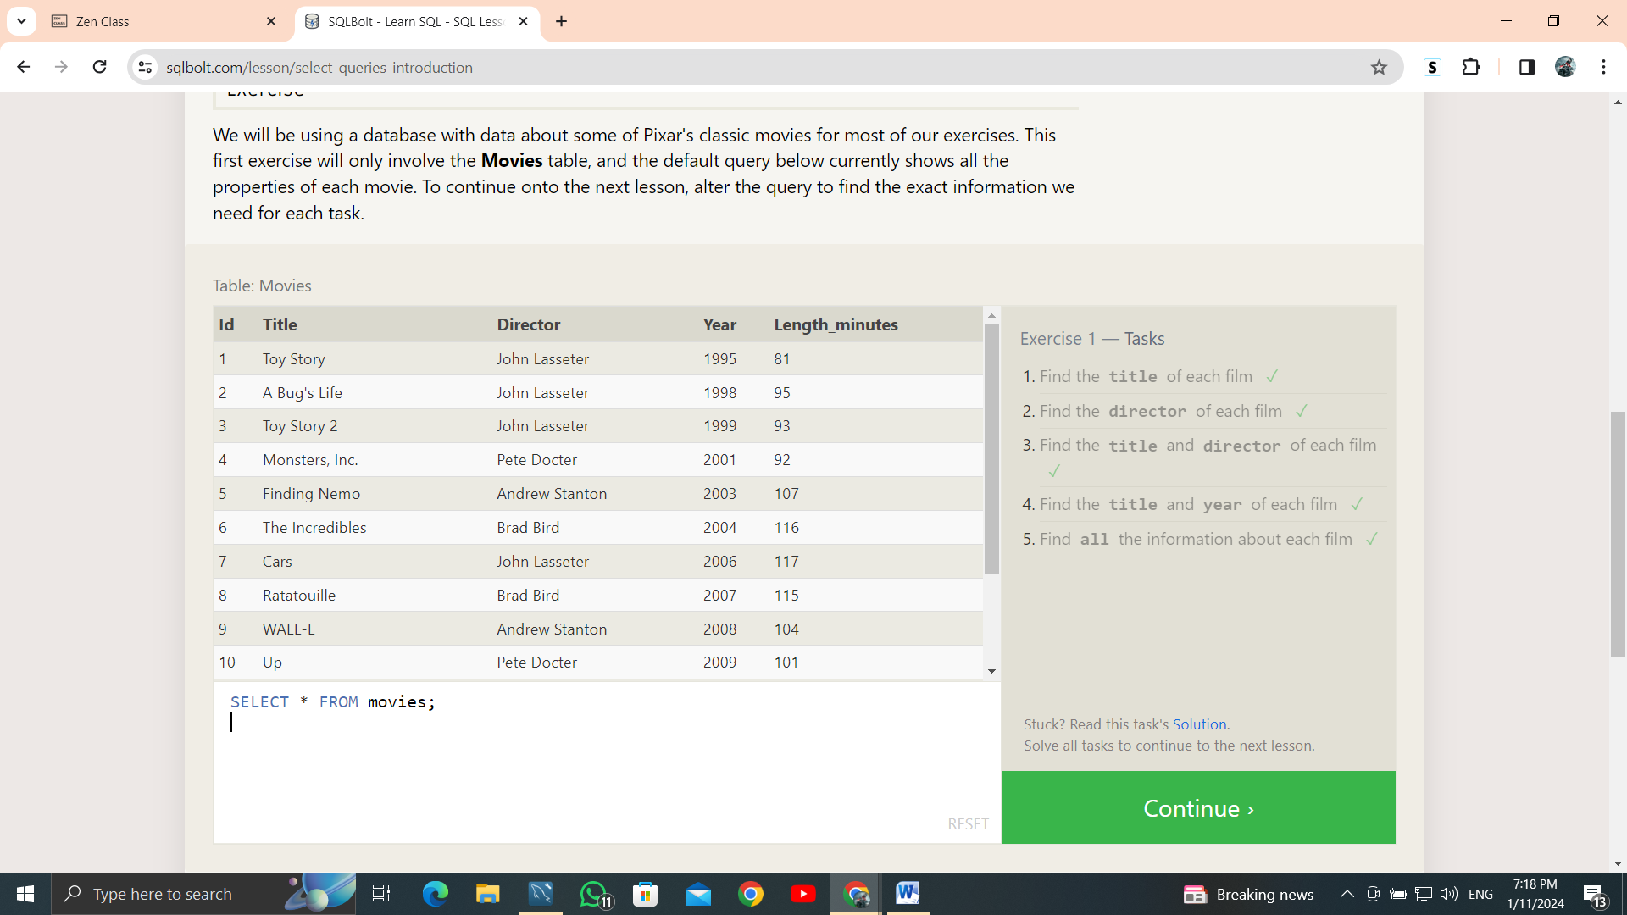

1. **SQL Lesson 2: Queries with constraints (Pt. 1)**

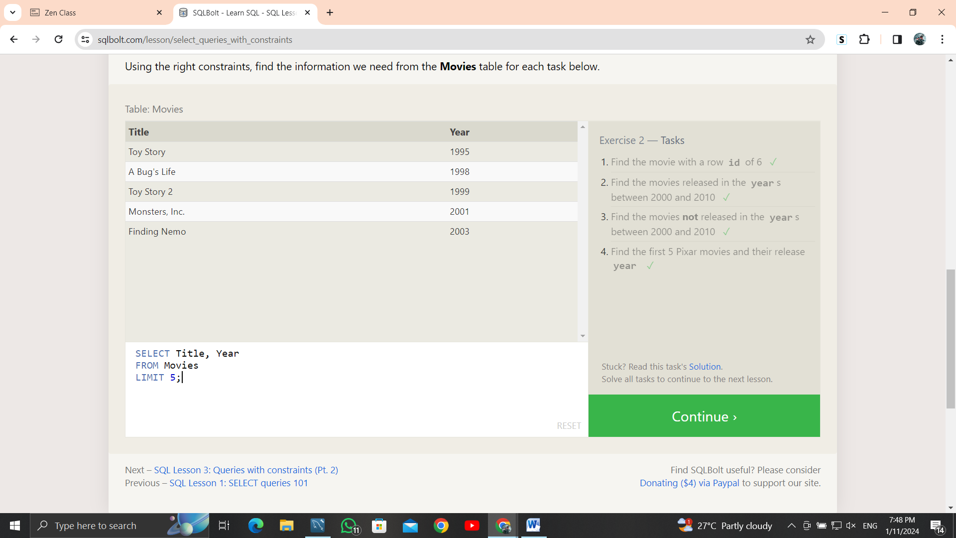

**3.SQL Lesson 3: Queries with constraints (Pt. 2)**

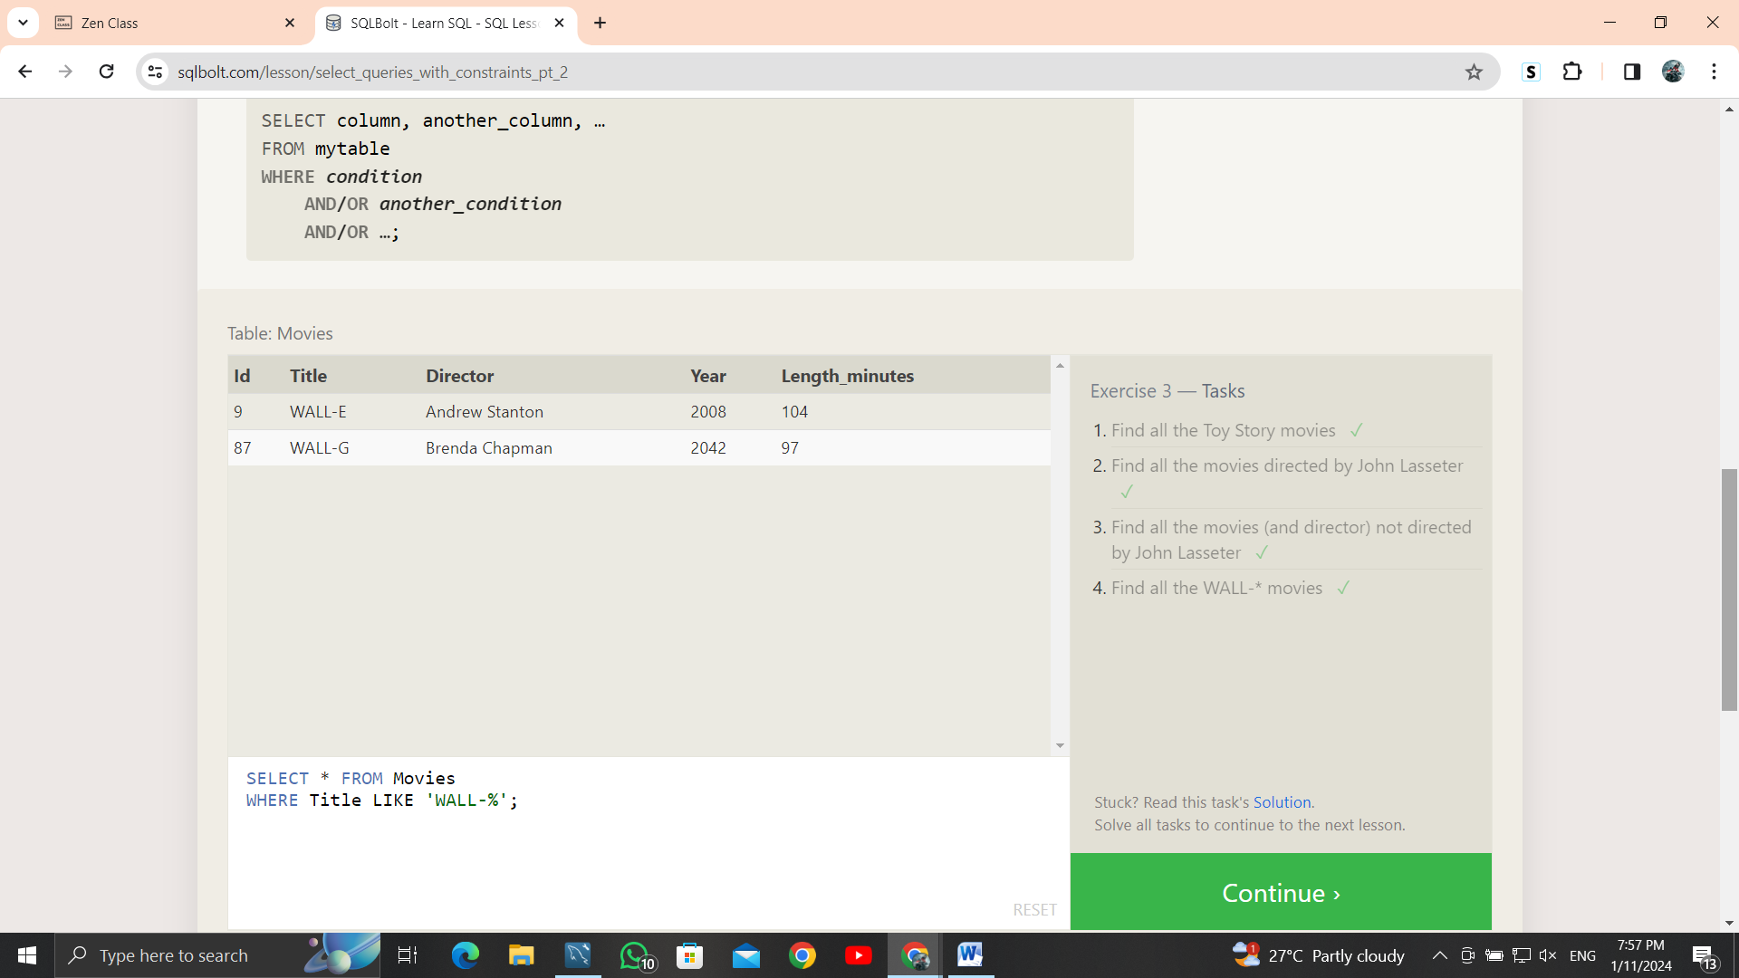

1. **SQL Lesson 4: Filtering and sorting Query results**

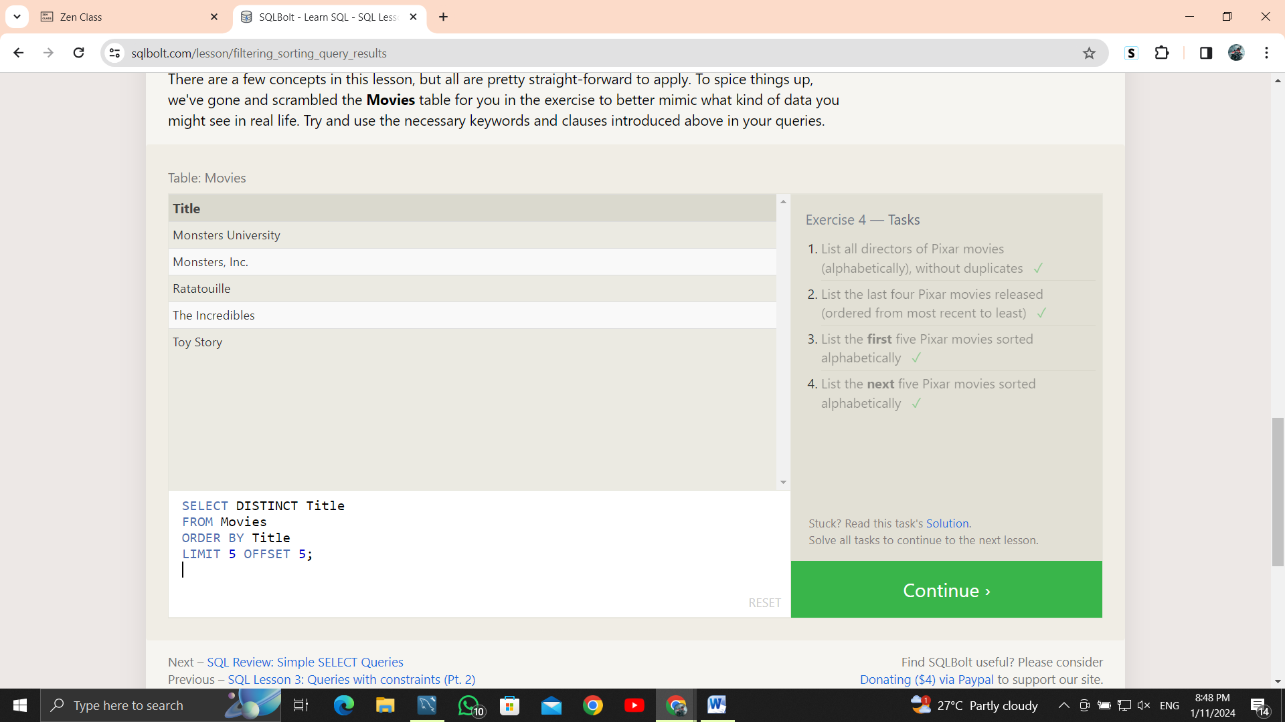

**5. SQL Review: Simple SELECT Queries**

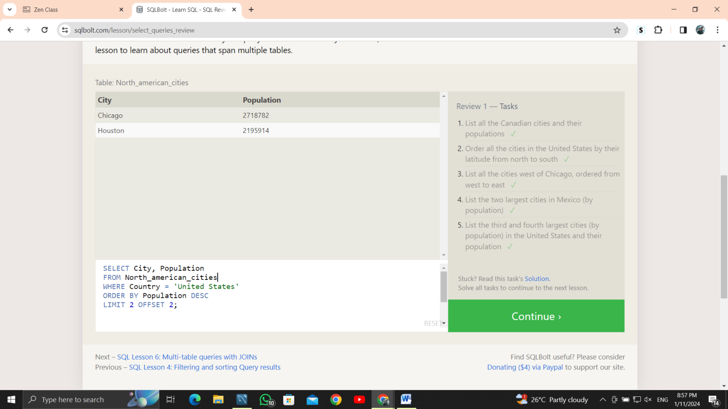

**6.SQL Lesson 6: Multi-table queries with JOINs**

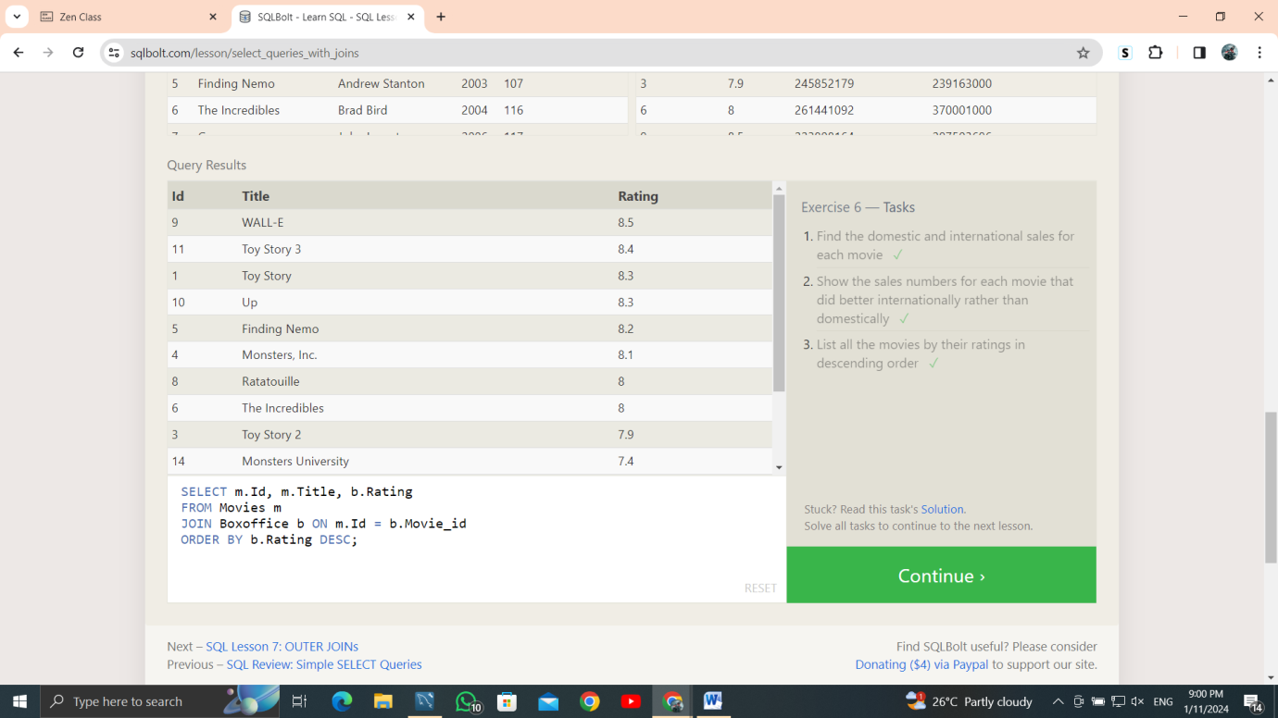

7. **SQL Lesson 7: OUTER JOINs**

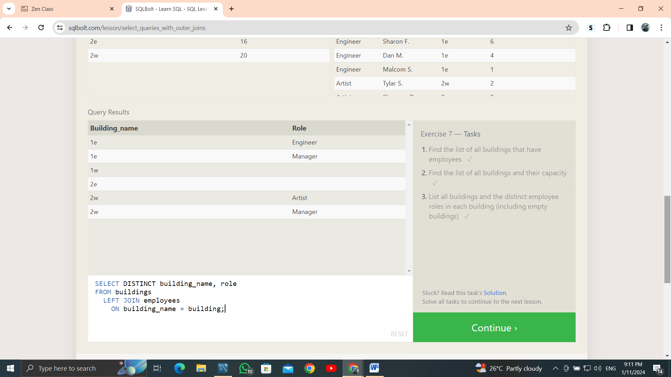

8. **SQL Lesson 8: A short note on NULLs**

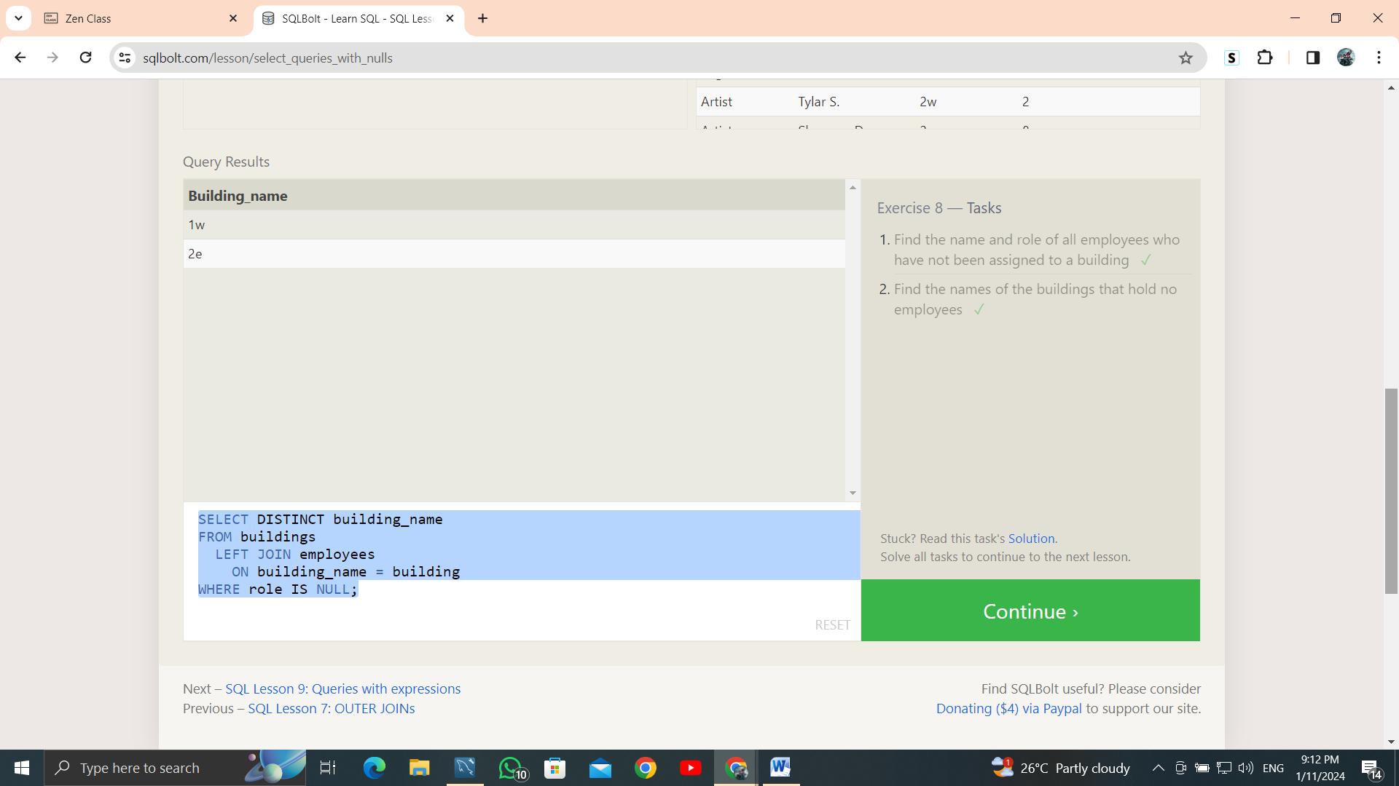

9. **SQL Lesson 9: Queries with expressions**

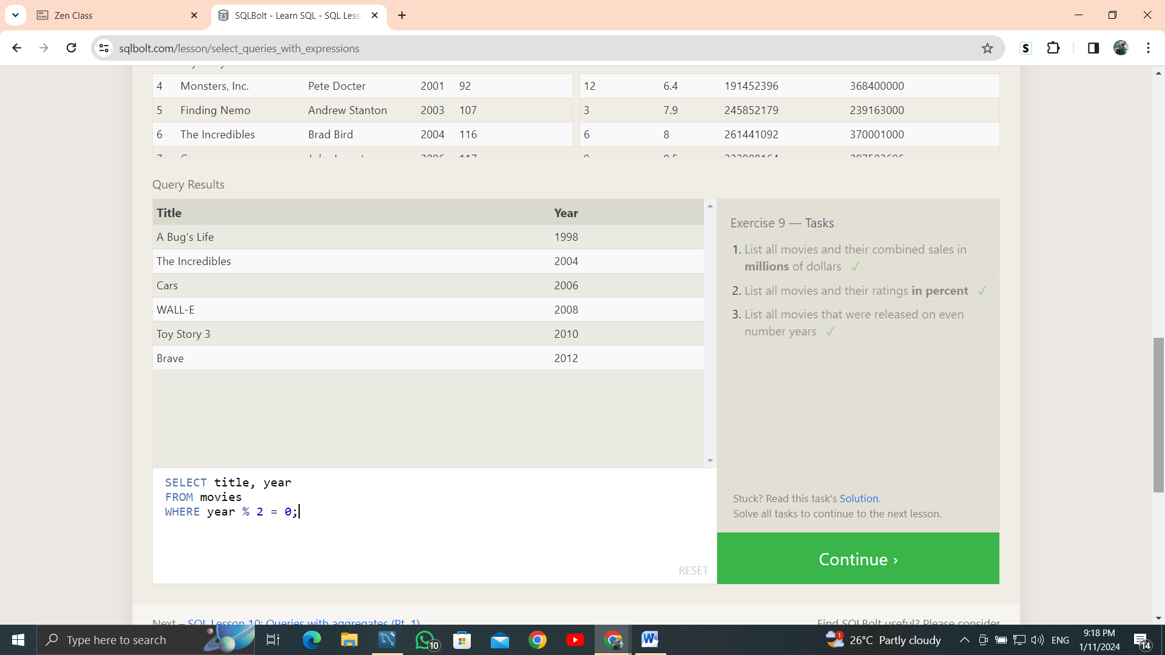

10. **SQL Lesson 10: Queries with aggregates (Pt. 1)**

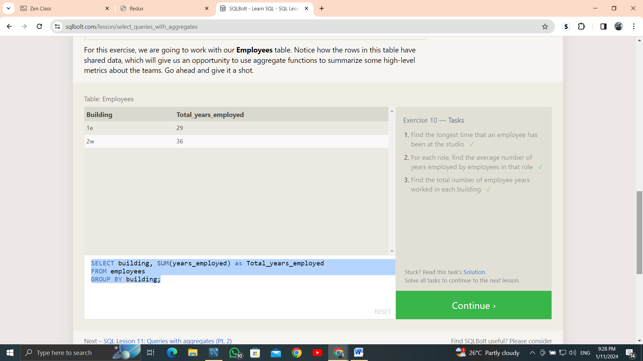

11. **SQL Lesson 11: Queries with aggregates (Pt. 2)**

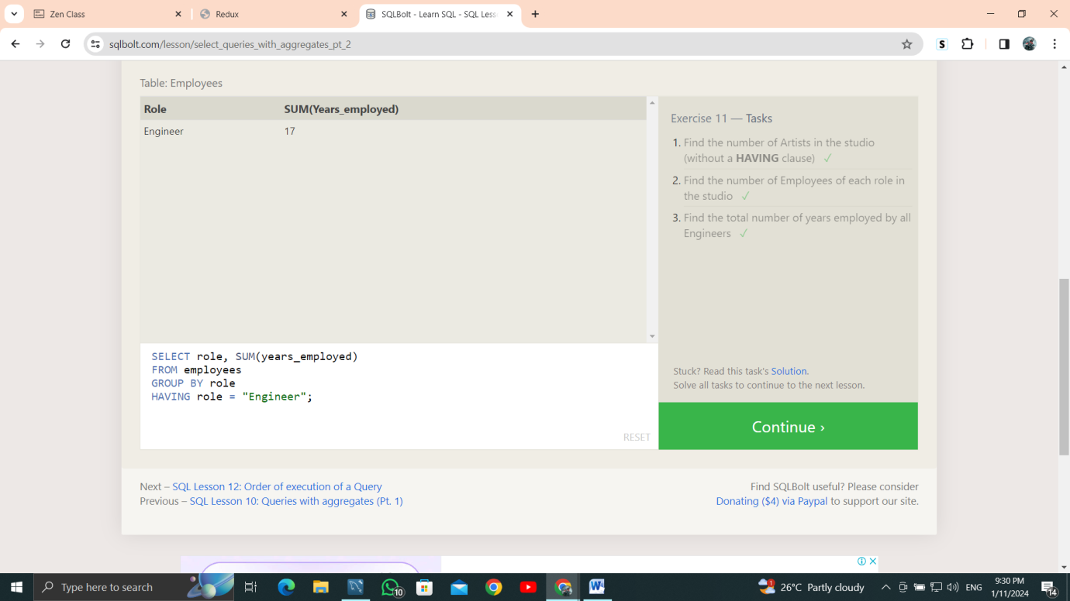

**12. SQL Lesson 12: Order of execution of a Query**

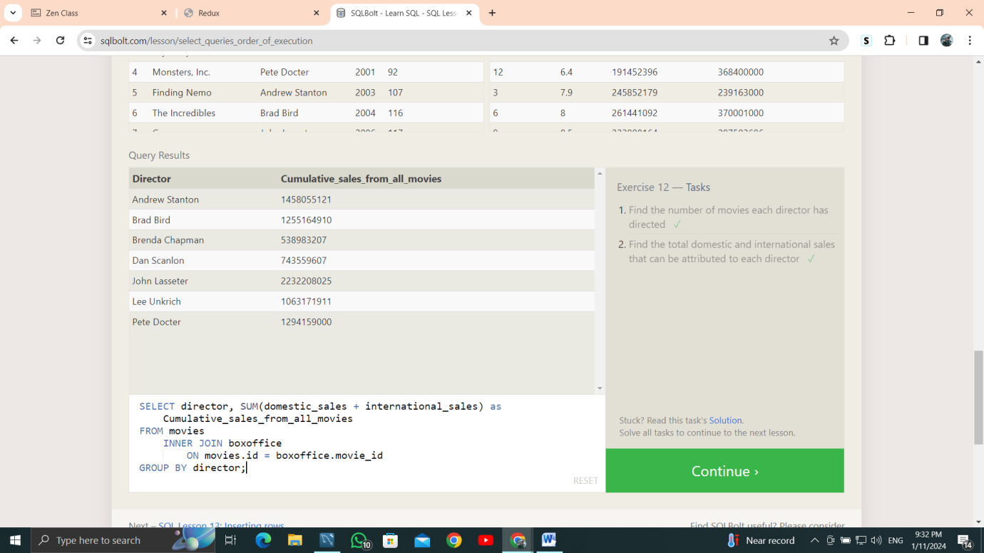

13. **SQL Lesson 13: Inserting rows**

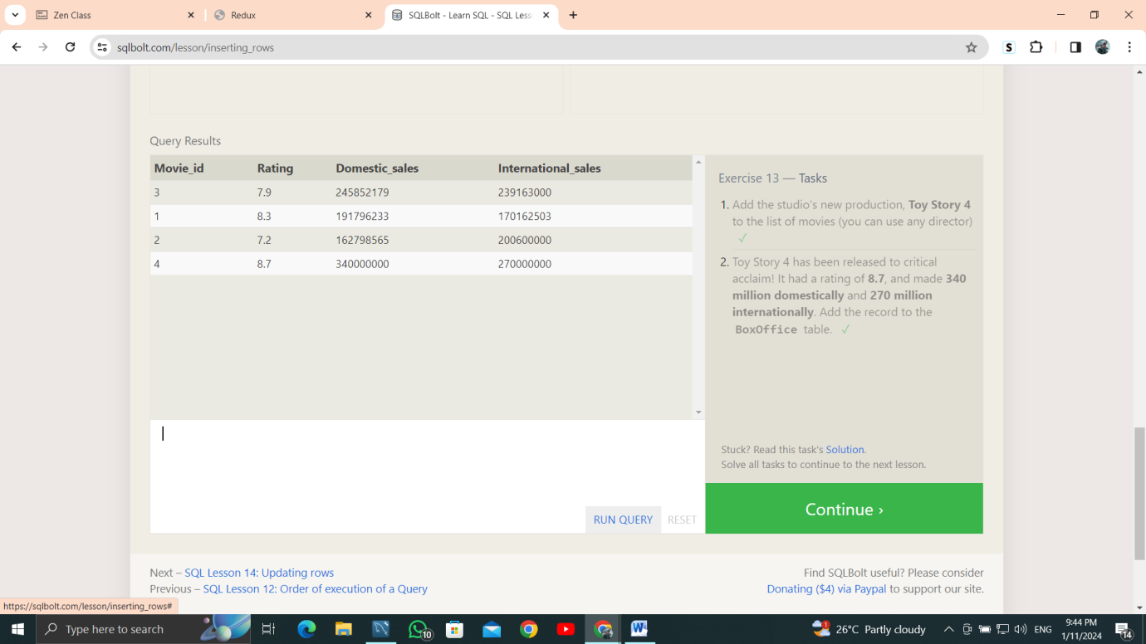

14. **SQL Lesson 14: Updating rows**

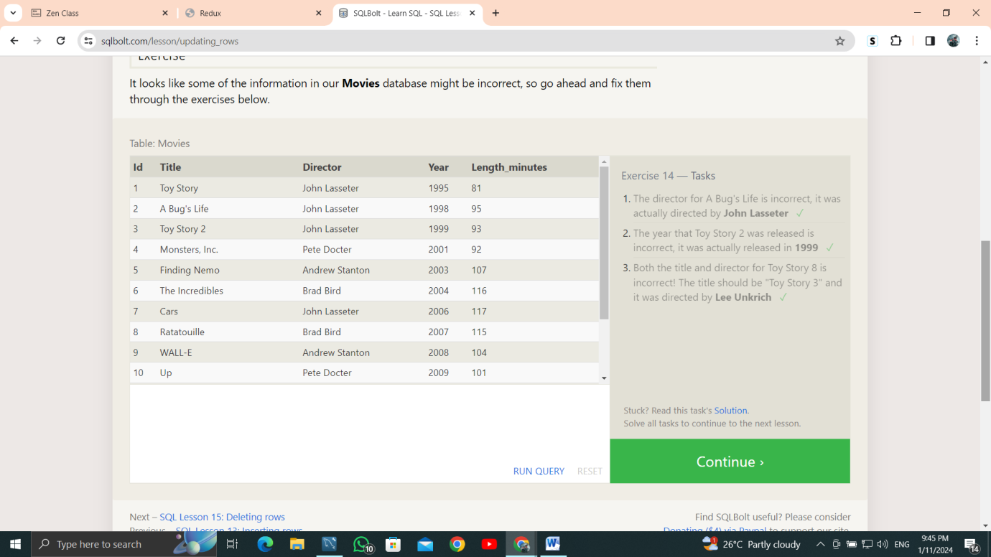

15. **SQL Lesson 15: Deleting rows**

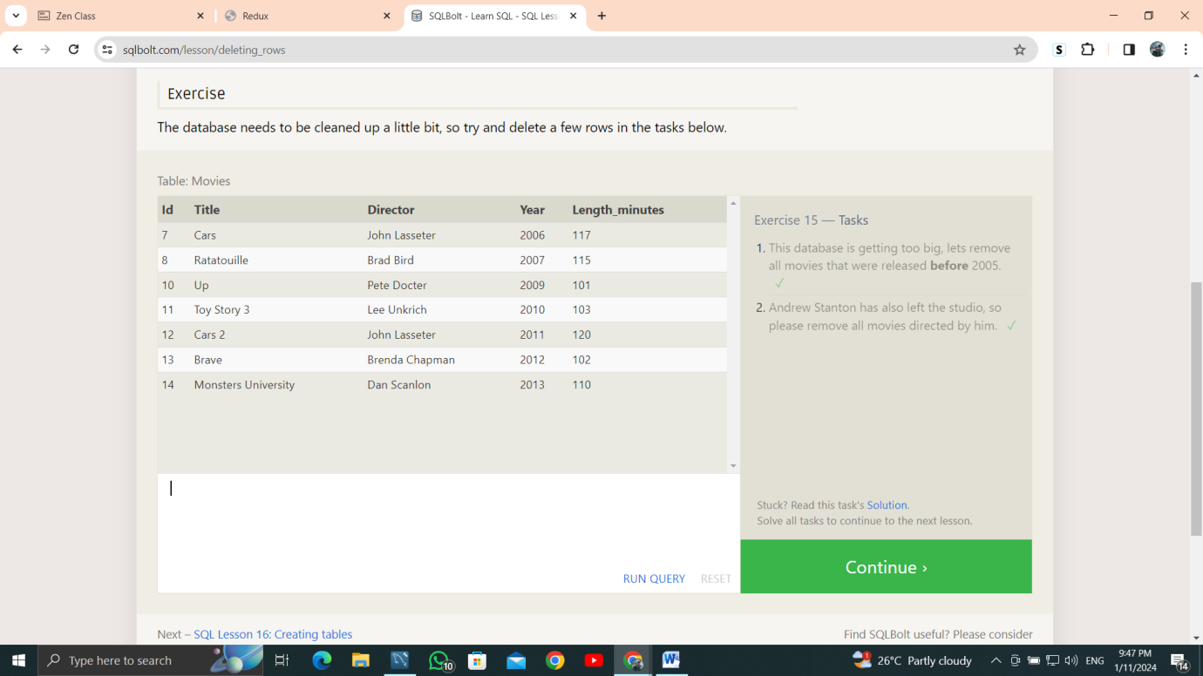

16. **SQL Lesson 16: Creating tables**

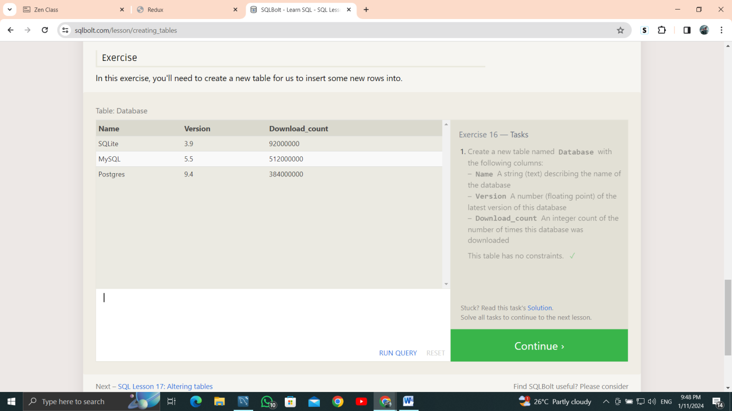

17. **SQL Lesson 17: Altering tables**

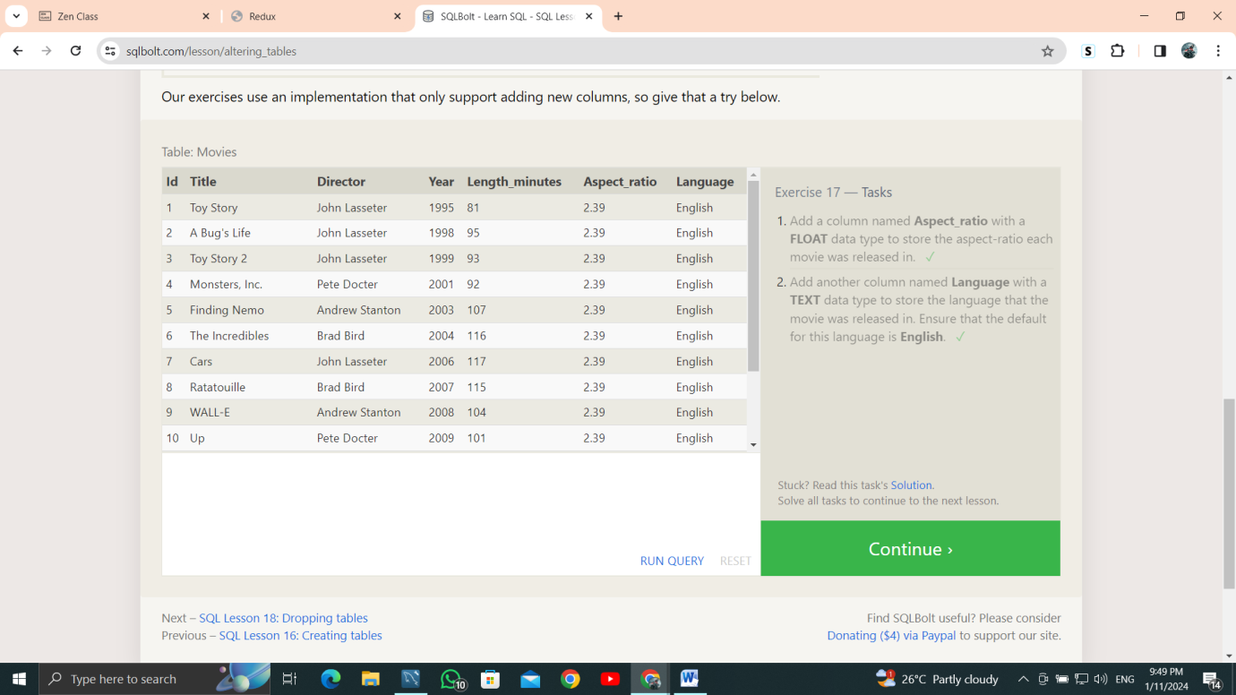

18. **SQL Lesson 18: Dropping tables**

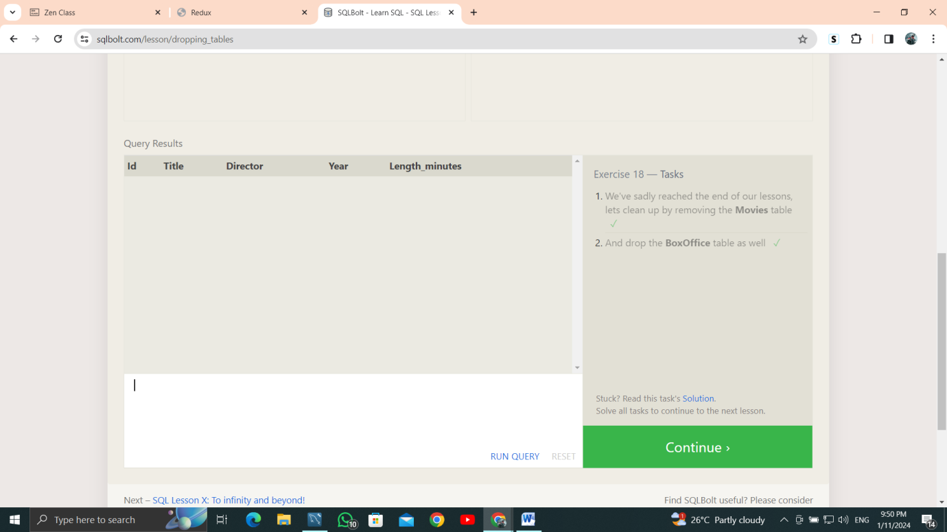

**SQL Lesson X: To infinity and beyond!**

